

**Ahsanullah University of Science and Technology**

*Department of Computer Science and Engineering*

CSE3200: Software Development-V

Spring 2021

PROJECT PROPOSAL

**Hotel Transylvania**

**Lab Section:** B2

**Group:** 05

**Submitted by**

|  |  |
| --- | --- |
| Sanjida Aziz Tonny | 180204122 |
| Md Zahidul Haque | 180204136 |
| S. M. Tasnimul Hasan | 180204142 |

30 January 2022

## Contents

1. Abstract 3

2. Features 3

3. Entity-Relationship Diagram 4

4. Future Work 5

5. Development Environment 5

6. Conclusion 5

**Abstract**

The project “Hotel Transylvania” is a web-based application that allows a user to reserve a room. Users can also learn about our hotel, our services & contact the hotel management for any kind of information. They can log in to our website by creating an account to access more features. There’s also have an admin panel. Admin can change or update the hotel services & also can edit or delete the booking information. Our website is convenient for users to reserve hotels without wasting their time.

# Features

* **Hotel services and details:** Users can know about the hotel and the services they are providing.
* **Gallery:** The user can see images of the hotel. With this feature, users can have a look at the hotel rooms and their atmosphere.
* **Room Details & Booking:** The user can know about availability, prices, and other details of the rooms from a different category. Users will be able to place the booking for available rooms in advance by sitting at home.
* **Contact:** There will be a contact section where anyone can contact to hotel authority for any issue by this website.
* **Login/Signup:** The user can create an account on the website with the necessary information. And user will be able to log in through the email and password of his/her account.
* **Admin Panel:** Admin can change or update the hotel services & also can edit or delete the booking information.

**Entity Relationship Diagram**

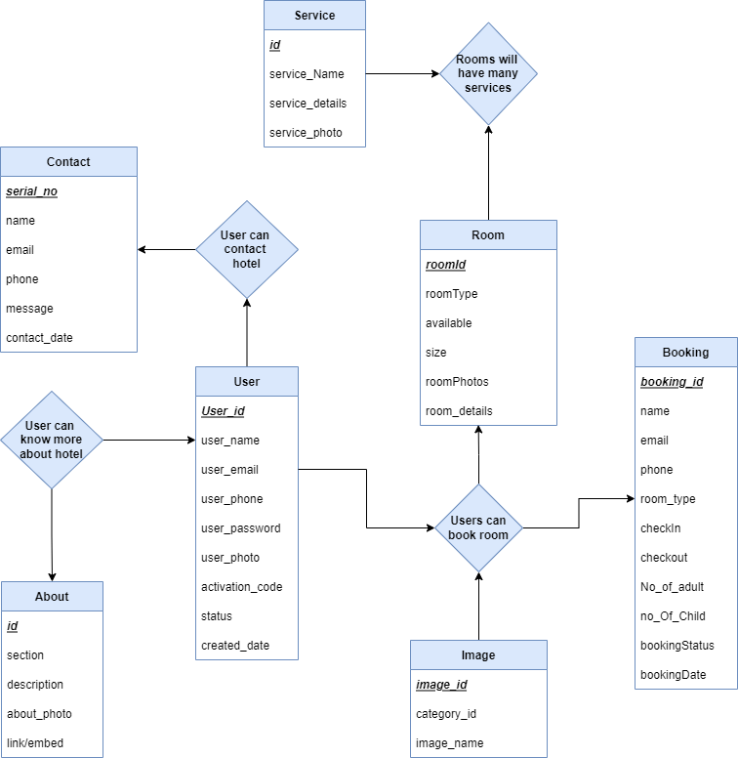

**Future Work**

* We will buy a domain and host the website.
* We will update our local database to the online server database.
* We will also update our UI & UX design in the future.

# Development Environment

* **Framework**

ASP.Net MVC

* **Language**

HTML, CSS, C#, Bootstrap

* **Database**

Microsoft SQL Server

# Conclusion

Through this project, we hope to demonstrate how hotel booking can be a hustle-free experience for both customers and the hotel management authority. Most of the Bangladeshi hotels do not have an online booking system, so now they will have an idea of how this system can be integrated easily.